Phase 1
First of all, we got the metaspoiltable3 ip, then we entered metaspoilt mode on kali, then applies the following steps shown in the snapshot below
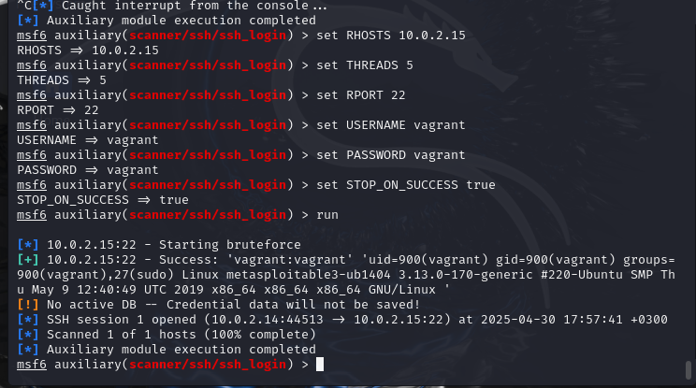
Screen shot of custom script:
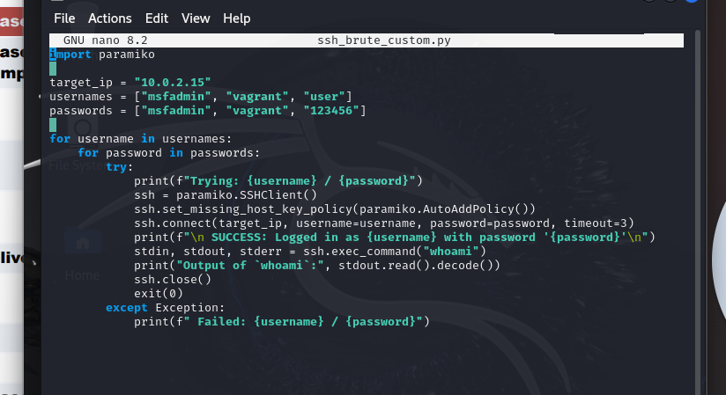

Screenshot of service compromise using custom script:
